**ADVANCED MICROPROCESSORS**

**SCHEME OF VALUATION**

**III SEM COMPUTER SCIENCE (NOV/DEC-2019)**

**CODE : I302**   **MAX.MARKS : 100**

**SECTION-I**

1.(a) (1x5=5) = 5 Marks

1.(b) Explanation = 5 Marks

**SECTION-II**

2.(a) figure(5m)+ explanation (5m) = 10Marks

2.(b) functions (1x5) = 5Marks

3. (a) figure (5m) + explanation (5m) = 10Marks

3. (b) List any five (1x5) = 5marks

4.(a) Diagram (6m)+ explanation(4m) =10Marks

4.(b) Explanation (5m) =5 Marks

**SECTION-III**

5.(a) Explanation Symbols (3m) + Variable (4m)+ Constants (3) = 10Marks

5.(b) List any five (1x5) = 5marks

6.(a) Explanation Any five(2x5) = 10Marks

6.(b List any five (1x5) = 5marks

7.(a) Explanation (5m)= 5 Marks

7.(b) Explanation Assembler (5m) + Compiler (5m)=10Marks

**SECTION – IV**

8.(a) . Explanation Interrupts(5m)+ Interrupts Actions(5m) = 10Marks

8. (b) Explanation (5m) = 5 Marks

9. (a) figure (5m) + explanation (5m) = 10Marks

9.(b). Any five comparison(1x5) = 5 Marks

10. (a) figure (6m) + explanation (4m) = 10Marks

10.(b) Explanation (5m) = 5 Marks.

**III Semester Diploma Examination, Nov/Dec -2019**

**ADVANCED MICROPROCESSORS**

**MOBILE COMPUTING (I302)**

**MODEL ANSWERS**

**SECTION-I**

1 (a) i American Standard code for Information Interchange

ii Memory Management Unit.

iii Assembler

iv Read only Memory

v END

1(b)

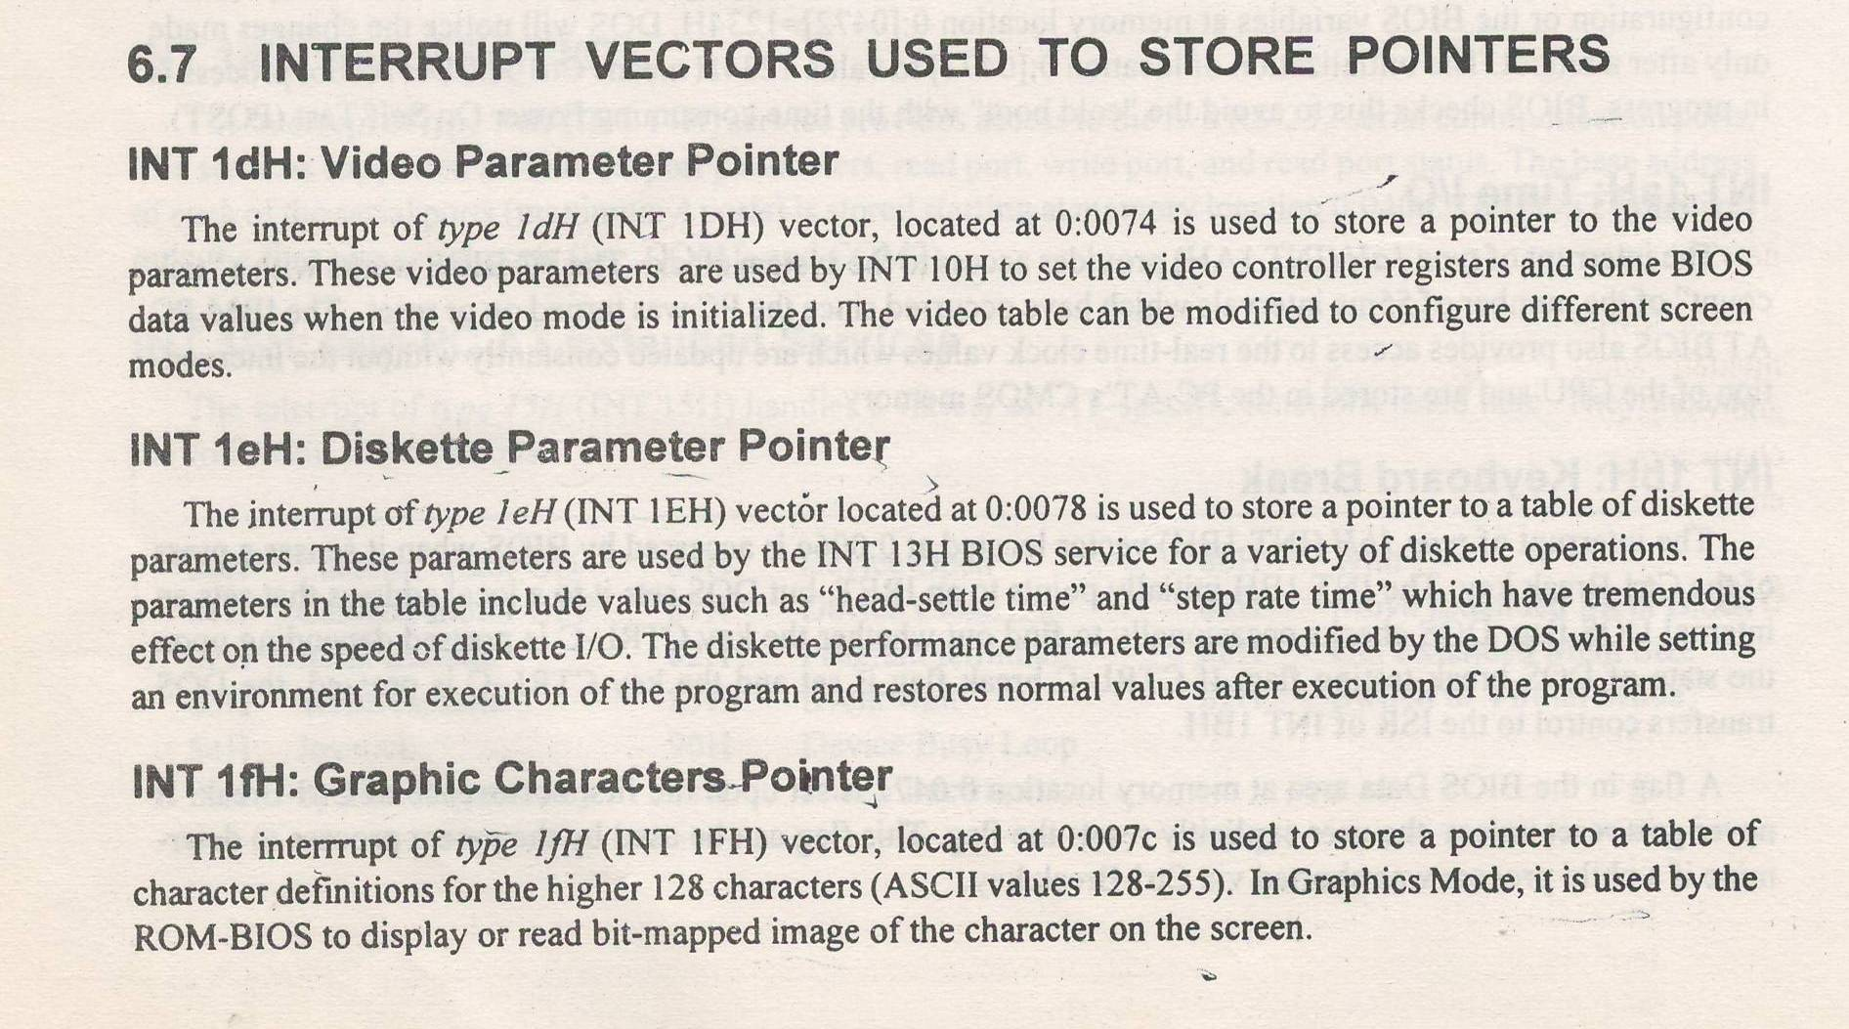

SECTION II

2(a)

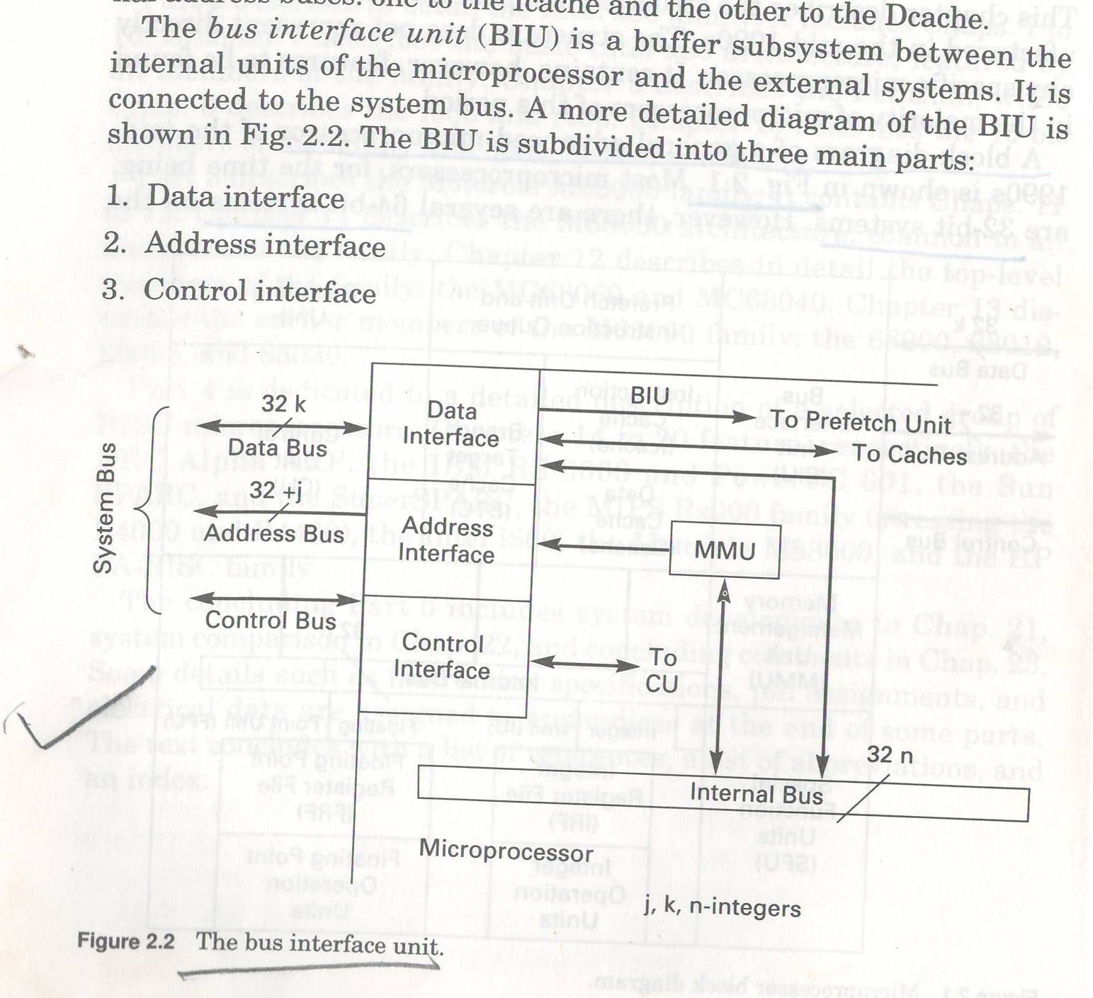

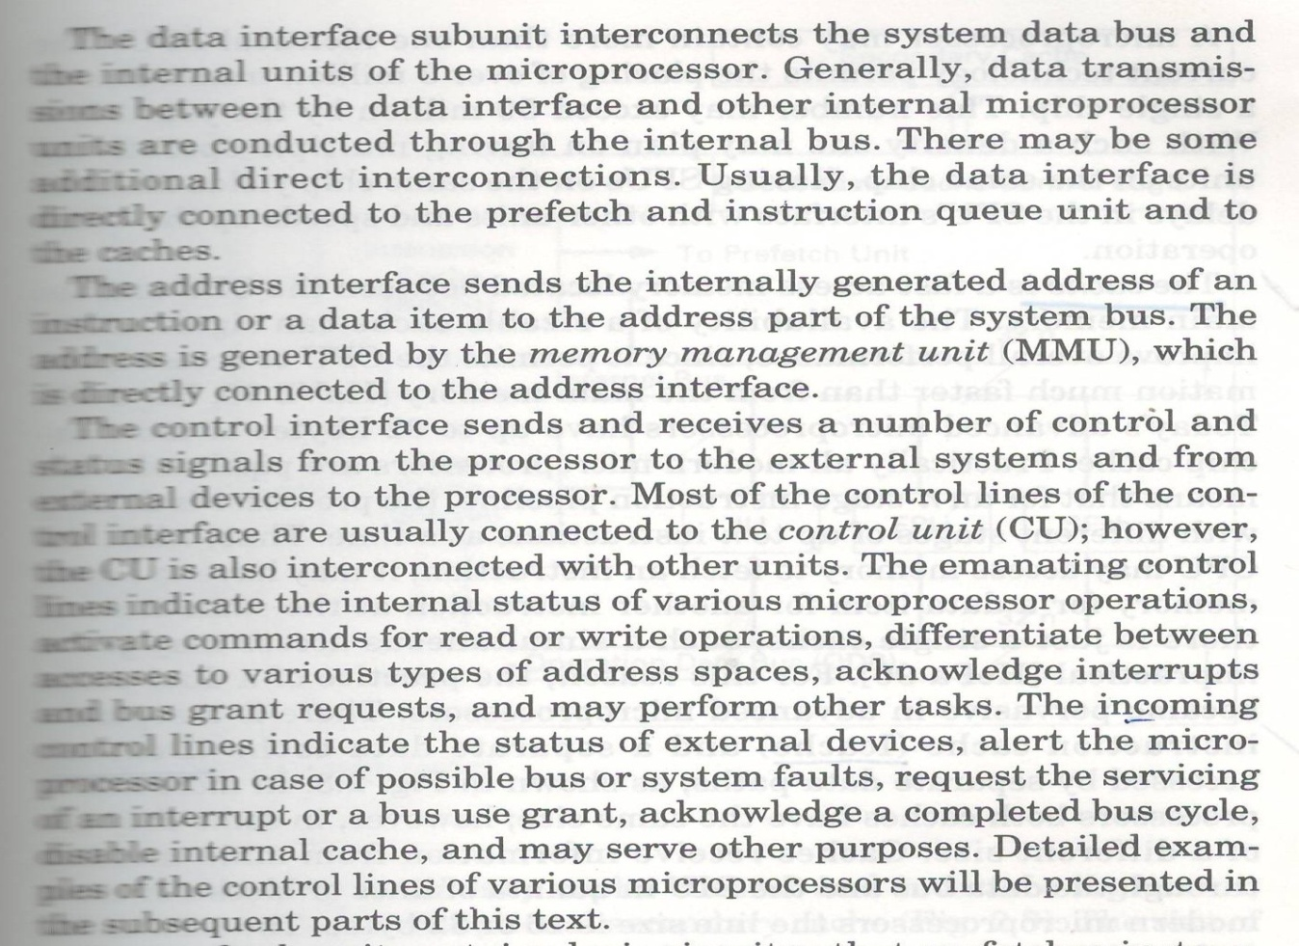

2(b)

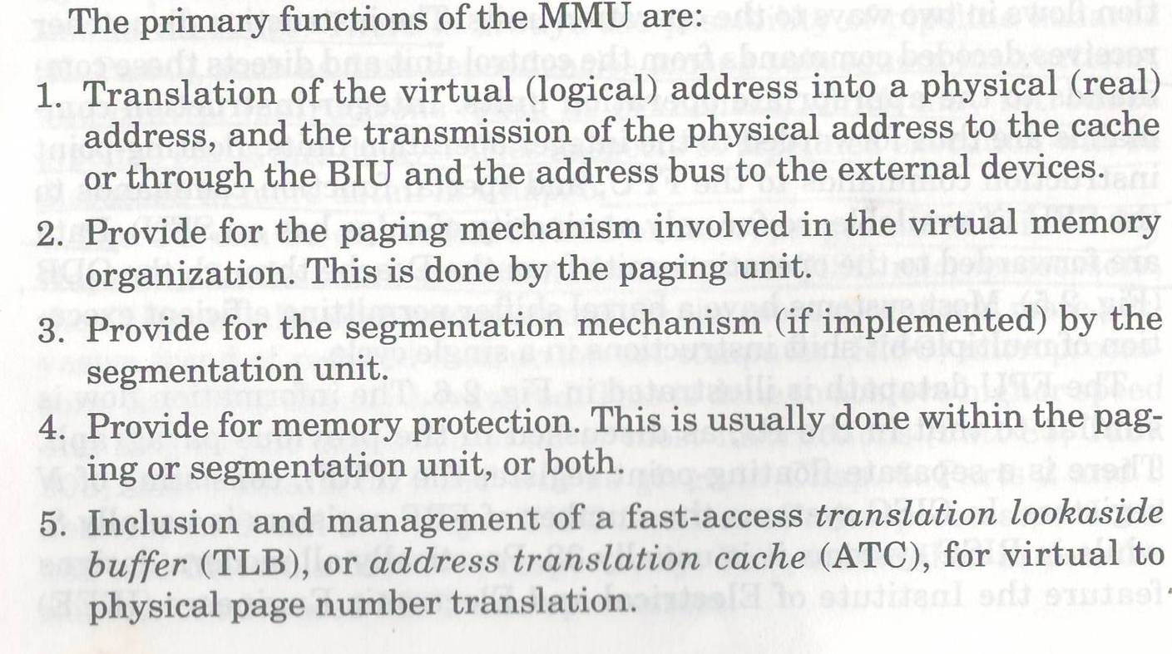

3(a)

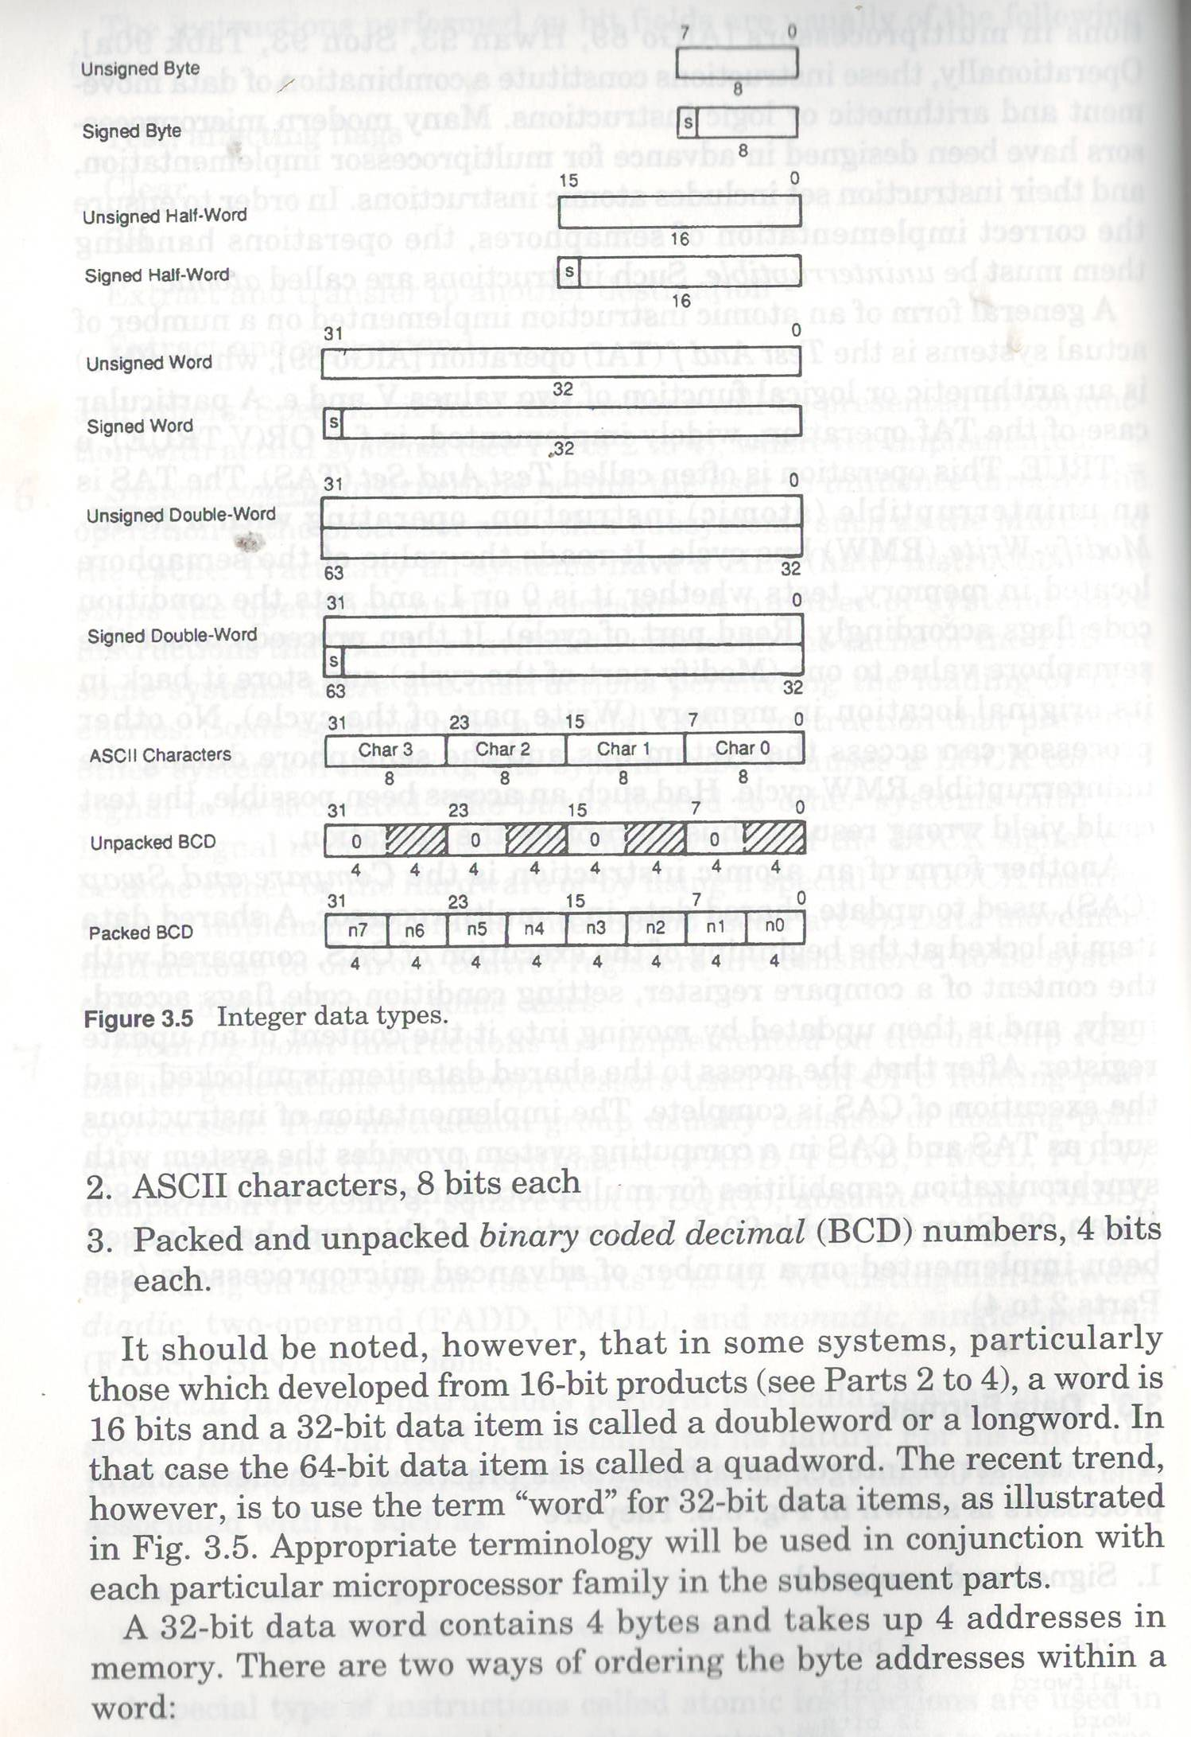

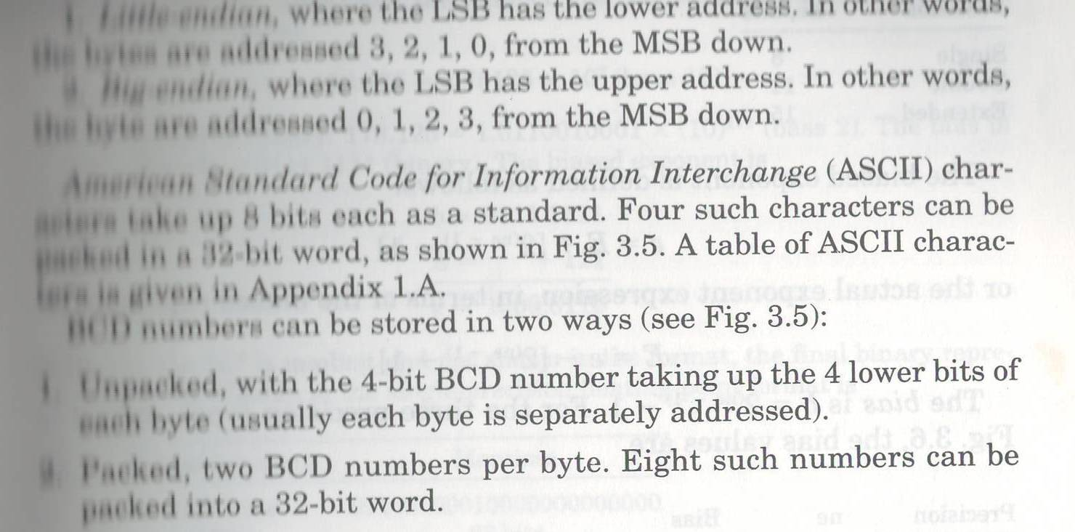

3(b)

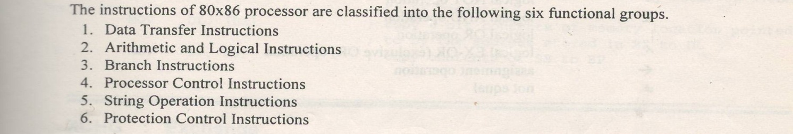

4(a)

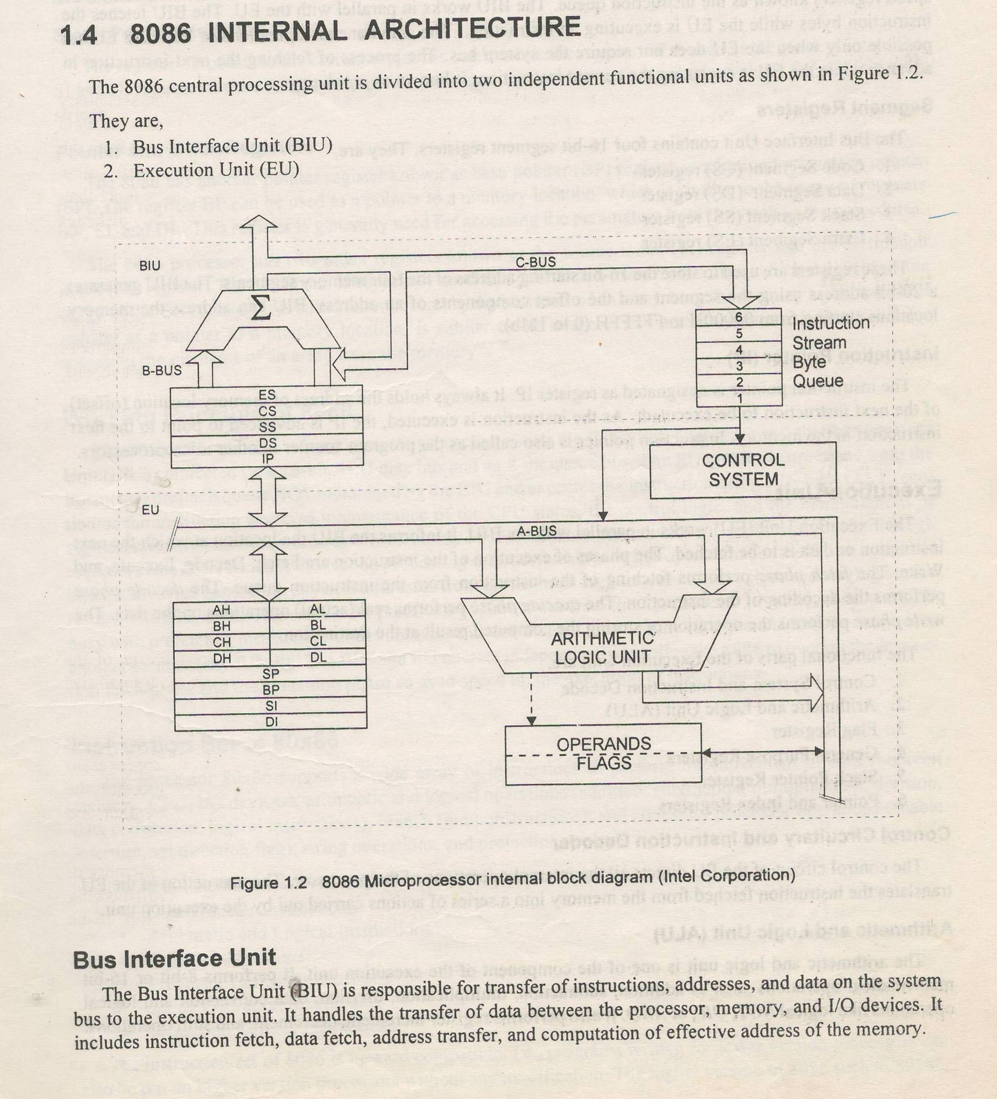

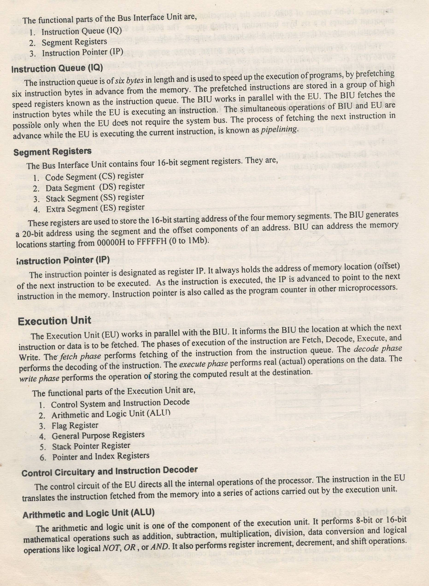

4(b)

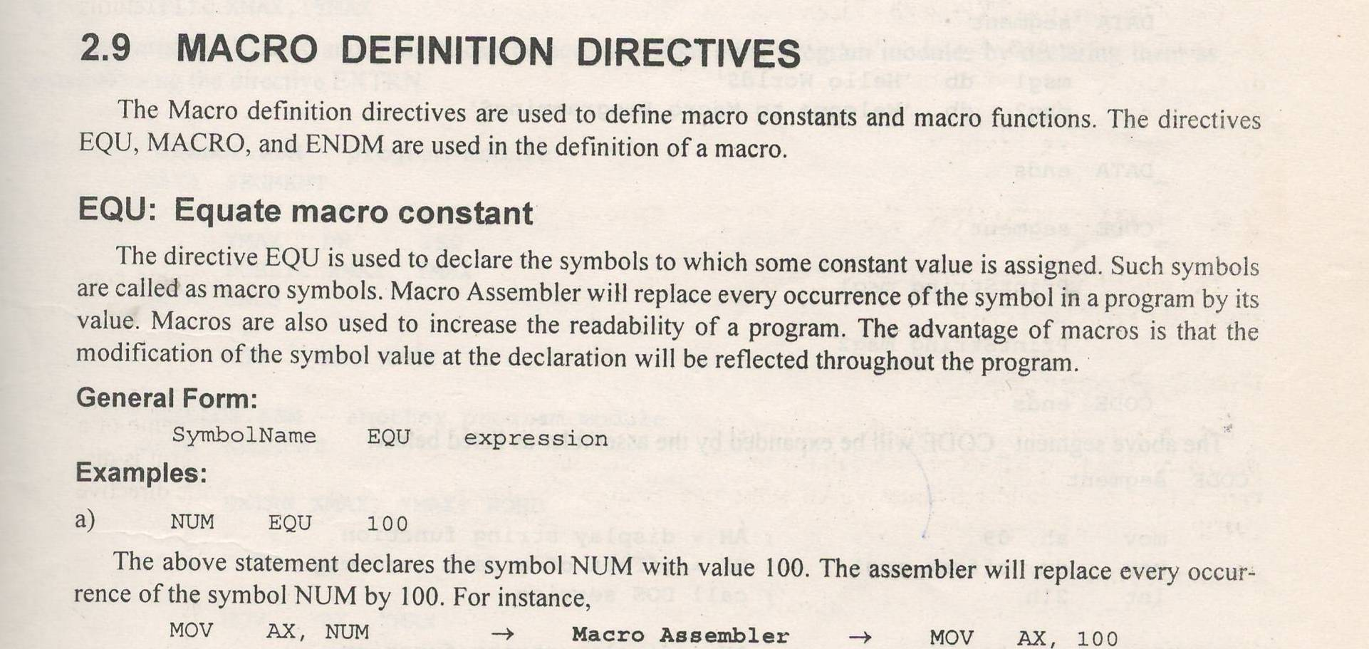

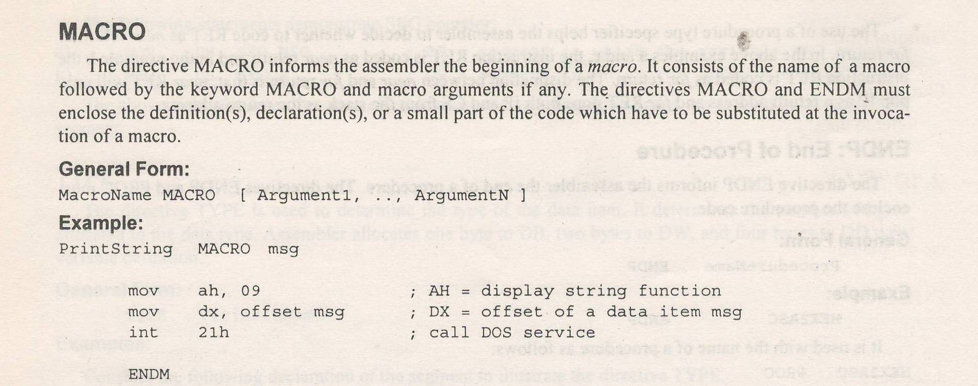

SECTION III

5(a)

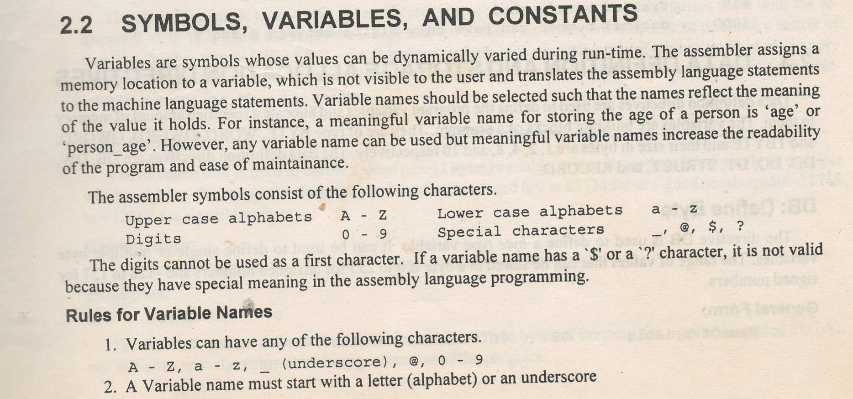

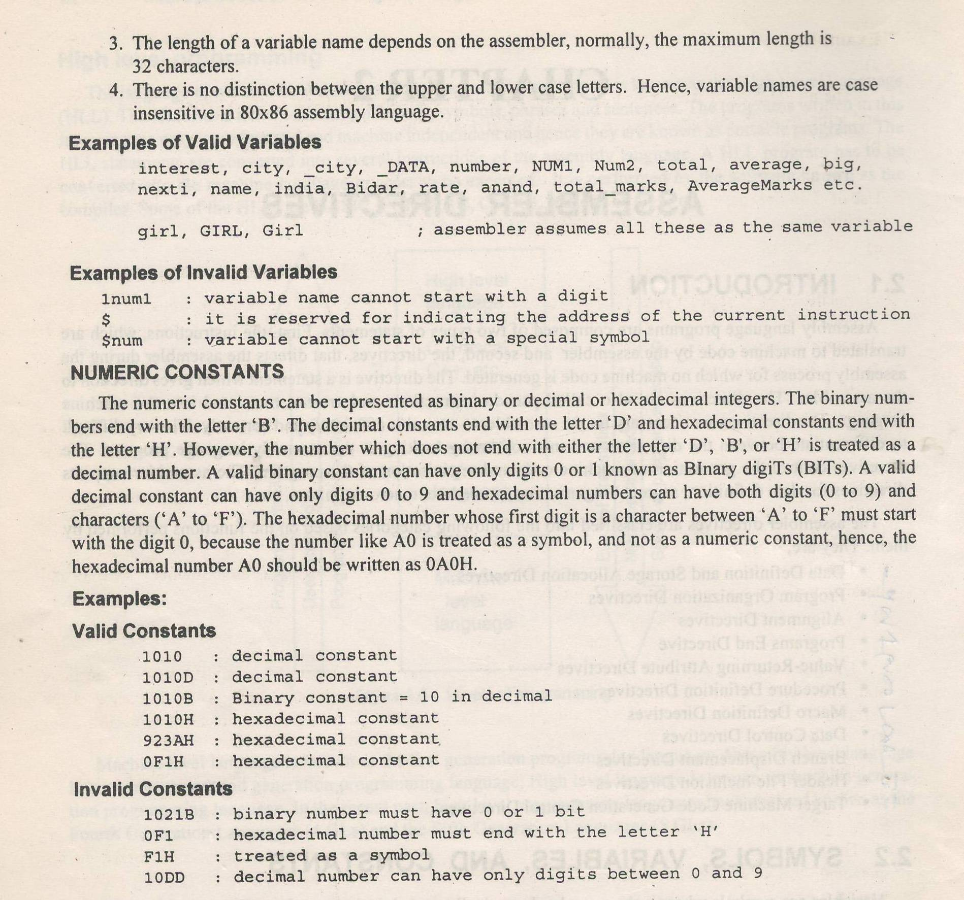

5(b)

Arithmetic Instruction of 8086 are

* ADD - DIV
* ADC - IMUL
* INC
* SUB
* SUBB
* CMP
* AAA
* AAS
* AAM
* AAD
* MUL

6(a)

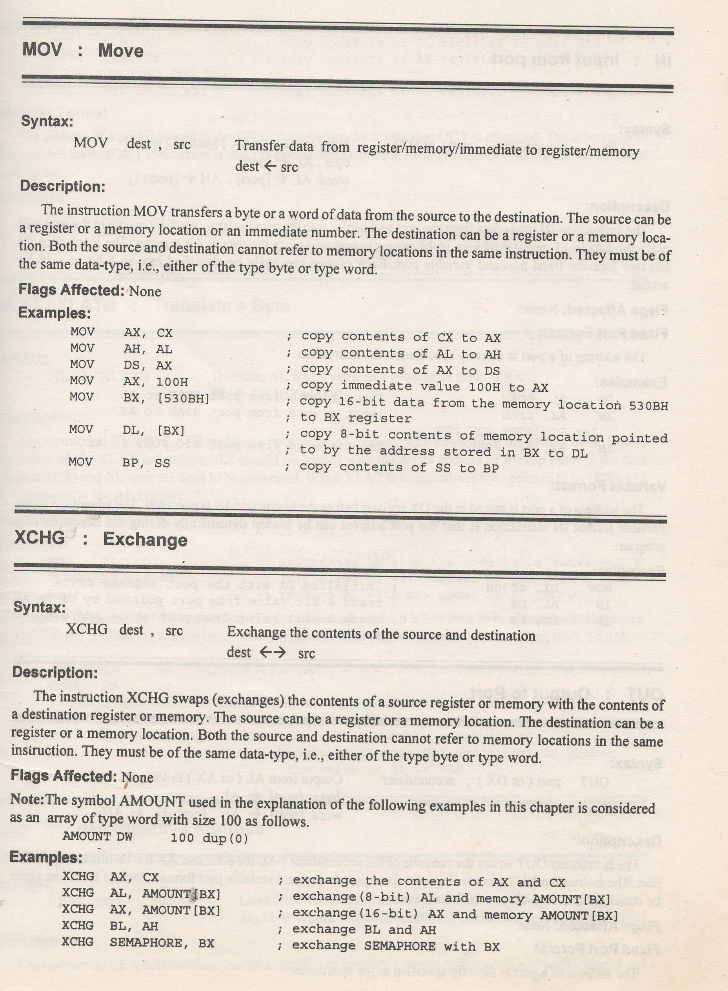

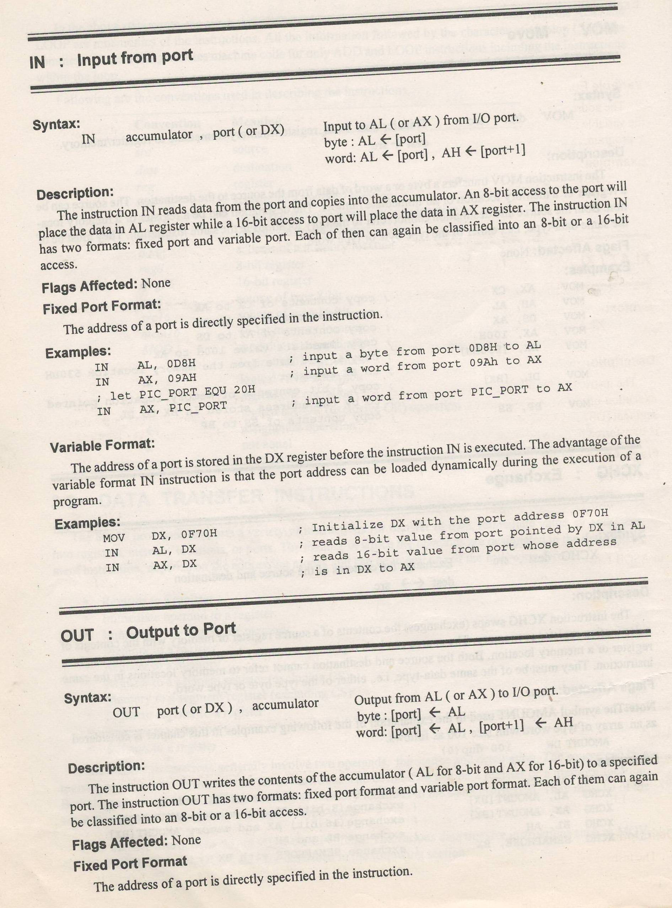

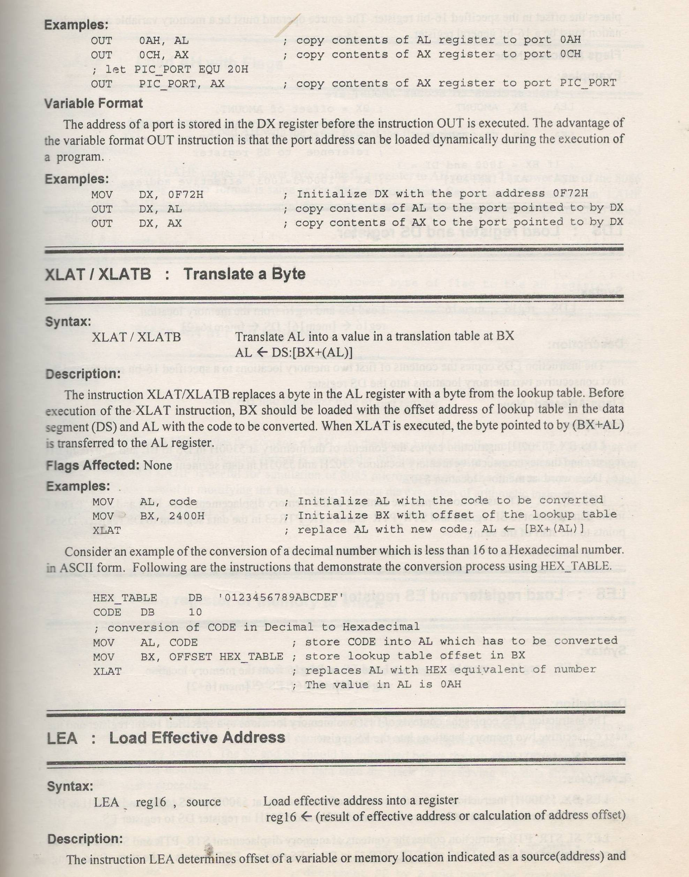

6(b) String Operation of 8086 are

- MOVS - SCAS

- MOVSB - SCASB

- MOVSW - SCASW

- LODS - INS

- LODSB - INSB

- LODSW - INSW

- STOS - OUTS

- STOSB -OUTSB

- STOSW -OUTSW

- CMPS

- CMPSB

- CMPSW

7(a)

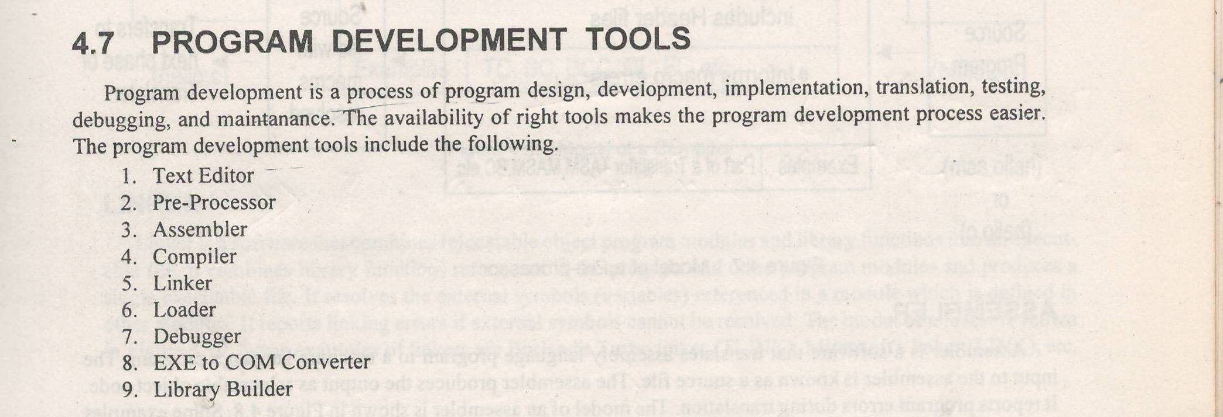

7(b)

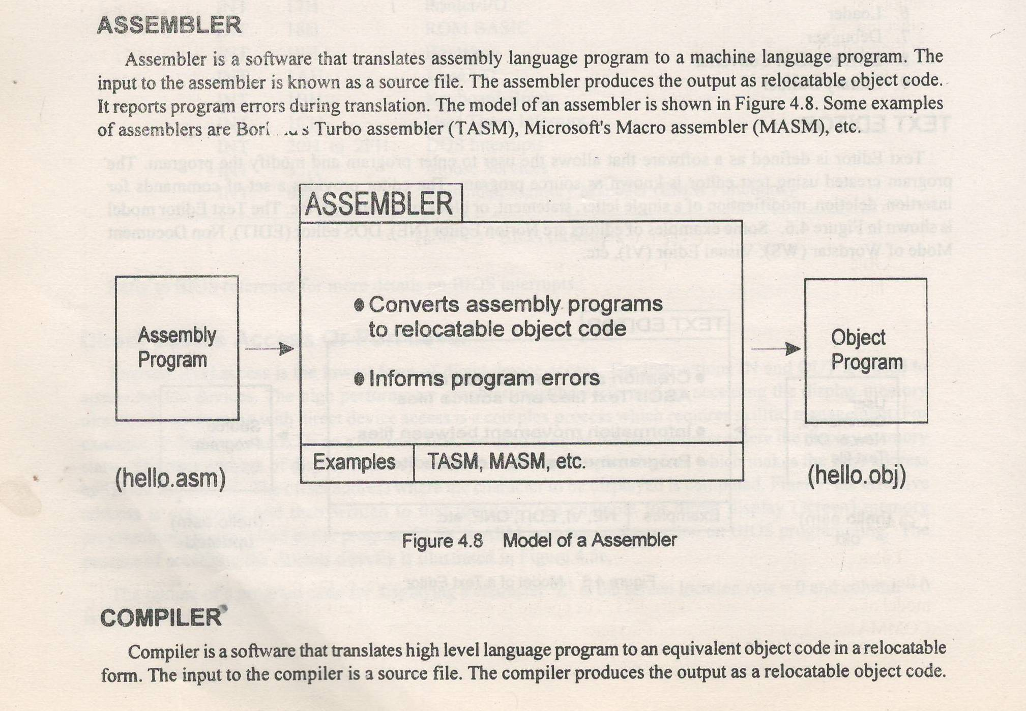

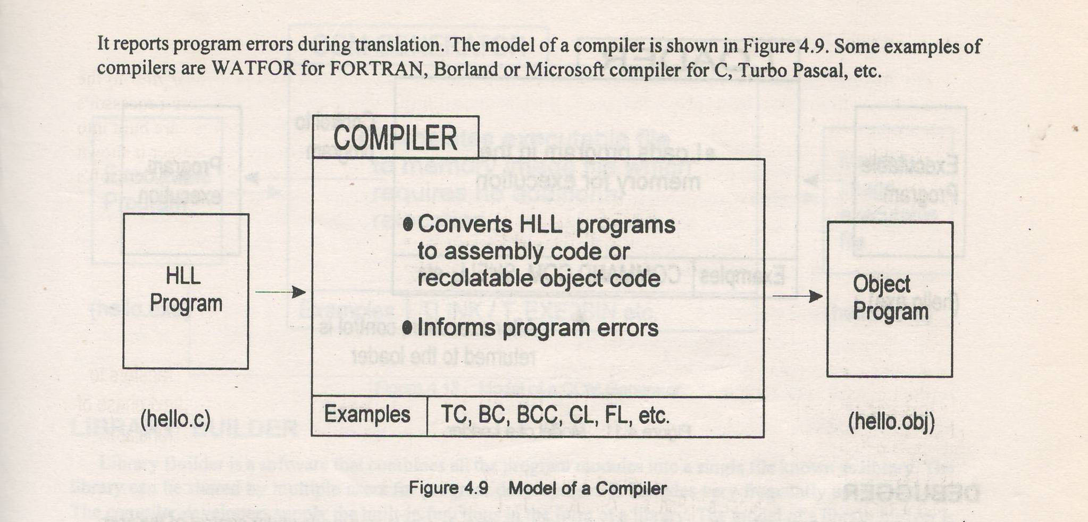

SECTIION IV

8(a)

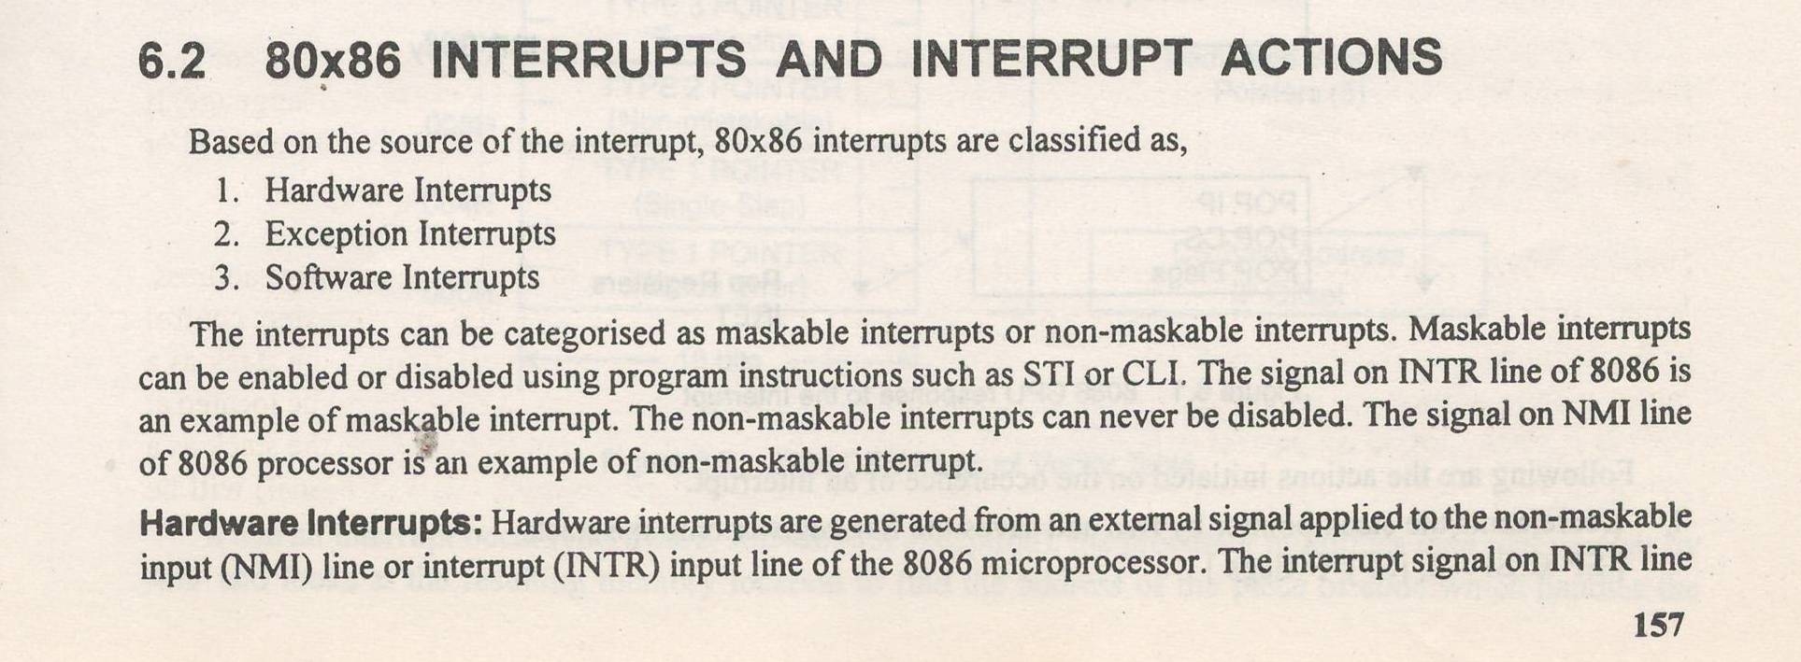

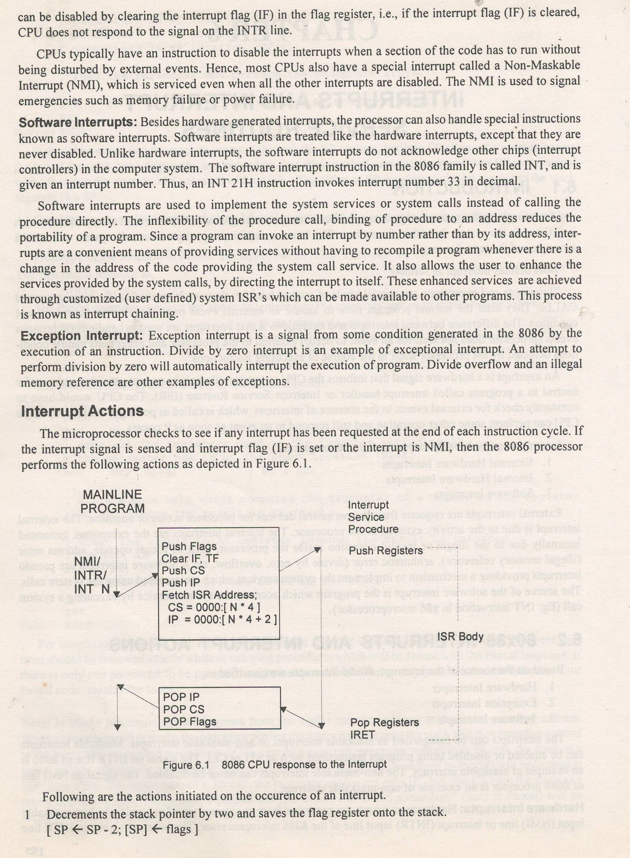

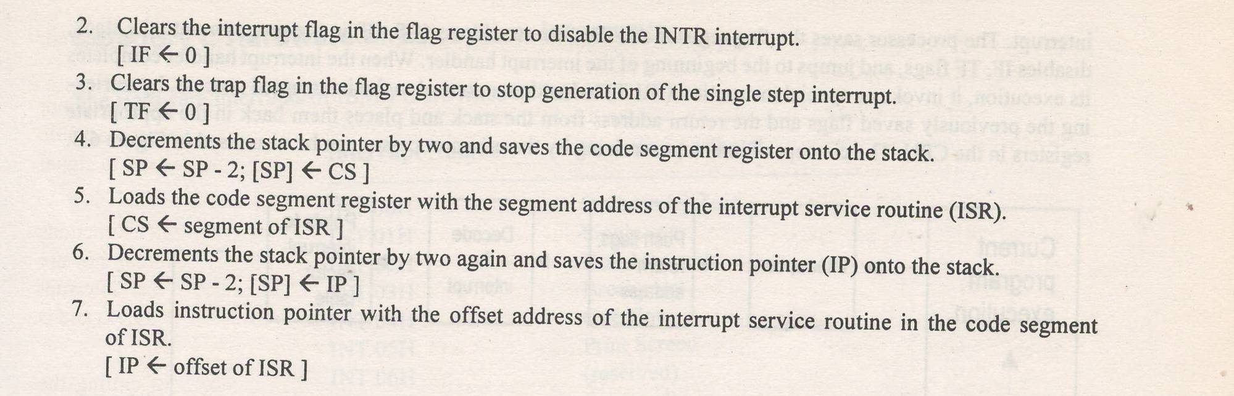

8(b)

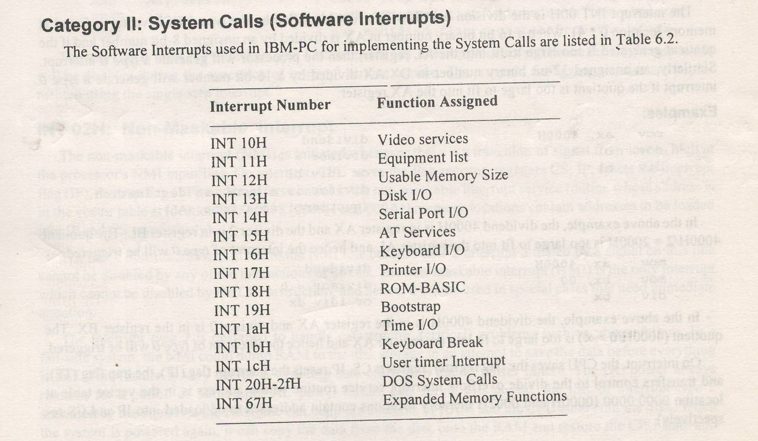

9(a)

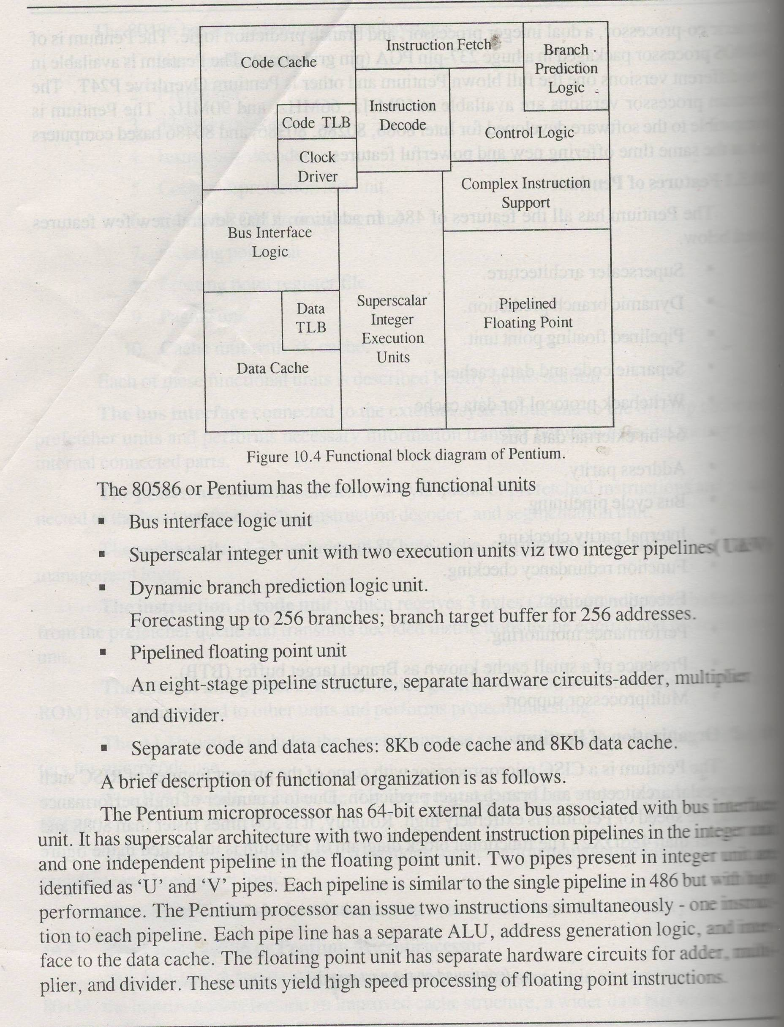

9(b)

| **Sr No.** | **Parameter** | **Pentium 2** | **Pentium 4** |
| --- | --- | --- | --- |
| 1 | Pipeline Stages | 14 (17 with load & store/retire) | 20 |
| 2 | Max. Clock | 450 MHz | 800~3000 MHz |
| 3 | Architecture | Intel's sixth-generation | Netburst microarchitecture |
| 4 | clock speeds | 233 MHz to 450 MHz | 1.3Ghz |
| 5 | 5 | processing capabilities | 32-bit |
| 6 | instruction set | - | SSE2 and SSE3 |
| 7 | FSB speeds | 66 MHz to 100 MHz | 400 MT/s to 1066 MT/s |

10(a)

A **superscalar architecture** includes parallel execution units, which can execute instructions simultaneously. ... However, most CISC-based processors (such as the Intel **Pentium**) now include some RISC **architecture** as well, which enables them to execute instructions in parallel.

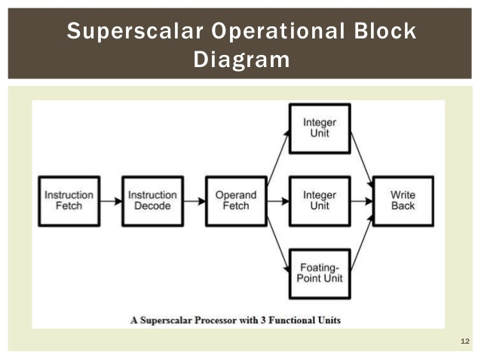

10(b)

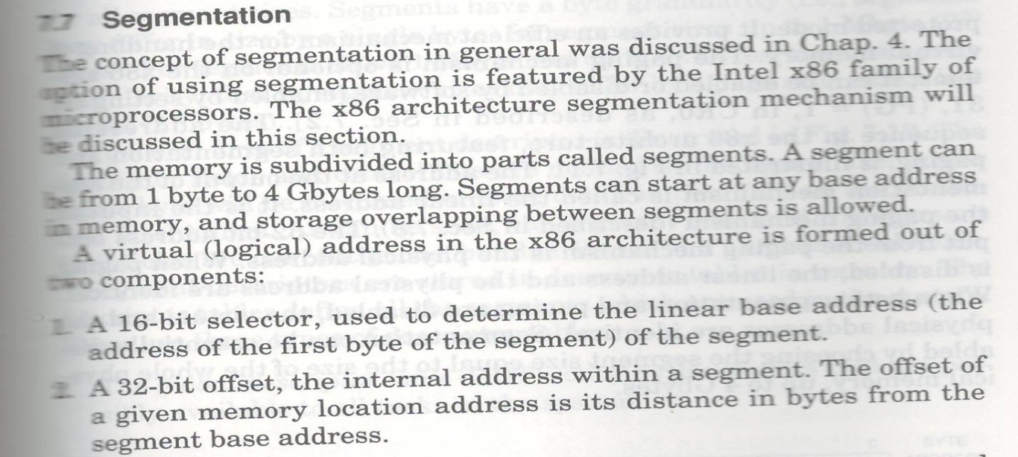

Certified that the model answers prepared by me for code no **I302** are from prescribed text book and model answers and scheme of valuation prepared by me are correct.



SHAMSHUD TABREZ

Selection Grade Lecturer

Computer Science

HMS Polytechnic, Tumkur